Toward Improving QoS and Energy Efficiency in Wireless Body Area Networks


Abstract—In high-stakes sensing environments, such as medical monitoring, the persistence of a Wireless Body Area Network (WBAN) is frequently compromised by the finite energy reserves of individual nodes and the volatility of mobile topologies. This study introduces the Particle Swarm Optimization-based Routing (PSOR) protocol, a strategy that moves beyond simple distance-based pathfinding to prioritize energy-balanced infrastructure. By interpreting the network as a region-based topology, our algorithm employs a specialized fitness function to reconcile transmission distance with real-time node energy states. We further implement a proactive recovery mechanism that identifies failing nodes and reroutes traffic to sustain connectivity. Simulations in the NS-2 environment confirm that our PSOR approach delivers superior reliability and lifespan compared to standard Genetic Algorithms.
Index Terms—Particle swarm optimisation, energy consumption, quality of service (QoS), wireless sensor networks (WSNs), wireless body area networks (WBAN).
- Introduction
A Wireless Sensor Network (WSN) consists of a large collection of small, autonomous sensing devices that are distributed across a target area to observe physical or environmental parameters such as temperature, sound, vibration, or pressure. These devices, commonly referred to as sensor nodes, can number from a handful to several thousand depending on the application. Each node integrates sensing components with a processing unit, wireless communication hardware, and a limited energy source, typically a battery. Depending on deployment requirements, WSNs may adopt simple centralized configurations or more complex multi-hop mesh topologies, where data is forwarded through multiple intermediate nodes before reaching a sink or base station. Owing to their flexibility and scalability, WSNs are widely employed in domains such as environmental monitoring, healthcare systems, disaster detection, and industrial automation.
One of the most critical design concerns in WSNs is energy management, as sensor nodes usually operate on non-rechargeable or difficult-to-access power supplies. Prolonging network lifetime therefore requires careful optimization of energy usage, often at the expense of traditional performance metrics such as latency or sensing resolution. In addition to energy constraints, WSNs must be capable of operating reliably under harsh environmental conditions, tolerating node failures, and adapting to node mobility. Despite these requirements, sensor nodes are limited by low processing capability, restricted communication bandwidth, and significant energy loss caused by idle listening, where power is consumed even in the absence of data transmission.
In many deployments, WSNs function as ad hoc networks, meaning they operate without fixed infrastructure and rely on decentralized coordination among nodes. Each node can serve not only as a data source but also as a forwarding entity, relaying packets on behalf of other nodes when direct communication with the destination is not possible. This cooperative forwarding mechanism results in a constantly evolving network topology, particularly in mobile environments, where routing paths must be updated frequently. Such ad hoc networking principles are applicable across a wide range of scenarios, including residential systems, enterprise monitoring, emergency response operations, and military communications, where adaptability, scalability, and security are essential.
For these networks to remain practical and efficient, routing protocols must effectively address three core challenges: extending network lifetime, ensuring robustness, and enabling autonomous operation. Since the failure of energy-critical nodes can disrupt overall connectivity, routing strategies must aim to reduce unnecessary power consumption, for example by placing radios into low-power states during idle periods. Robustness is equally important, as the network must continue functioning despite node or link failures. Furthermore, self-configuration capabilities are required so that the network can respond to changes in topology without manual reprogramming. This work tackles these challenges by introducing an intelligent routing mechanism that seeks to balance energy usage with communication efficiency.
The central goal of this research is to enhance the operational efficiency of Wireless Sensor Networks while maintaining high Quality of Service (QoS) and secure data transmission. To achieve this, we propose a routing framework in which sensor nodes make informed, logic-driven decisions during packet forwarding. The proposed method combines a graded routing strategy with Particle Swarm Optimization (PSO) to identify energy-aware and reliable routing paths. By distributing traffic across suitable nodes rather than repeatedly relying on a small subset of routes, the approach prevents premature energy depletion and promotes uniform energy consumption throughout the network. As a result, the proposed scheme reduces maintenance overhead, avoids node overuse, and significantly improves the overall longevity and performance of the network.

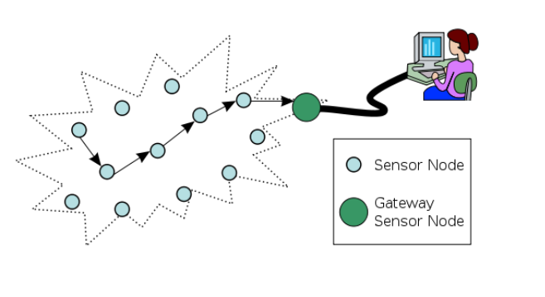
Fig 1: WSNs
- Related Work

A. Intelligent SDN Architectures for Heterogeneous Management
The decoupling of control and data planes through Software-Defined Networking (SDN) has become a primary solution for managing the complexity of 5G and heterogeneous sensor infrastructures. Sun et al. [1] proposed an intelligent model that centralizes resource management to handle the dynamic nature of 5G services, improving traffic control and subscriber management. Building on this, DeGante et al. [4] introduced a generic base station architecture specifically for WSNs, placing the controller at the sink to alleviate the management burden on individual nodes. Efficiency: These frameworks are highly efficient in large-scale deployments as they replace local, computationally expensive routing logic with a centralized, global view. Relevance: This architectural approach justifies the centralized logic of the PSOR algorithm, where a high-level view of node energy and path fitness is required to make optimal routing decisions across the entire network.

B. Distributed Security and Privacy-Preserving Schemes
Security in decentralized networks must balance data integrity with the energy limitations of sensor nodes. Li et al. [2] introduced the EPPDR scheme, which employs homomorphic encryption—allowing data aggregation without decryption—to ensure privacy and forward secrecy in smart grids. To prevent the control plane from becoming a bottleneck, Fawcett et al. [3] developed TENNISON, a distributed SDN security framework that spreads monitoring and remediation tasks across multiple points. Furthermore, Pritchard et al. [5] addressed control channel vulnerabilities using the Host Identity Protocol (HIP) and IPsec tunneling. Efficiency: These methods demonstrate that security does not necessarily require massive overhead; distributed monitoring and lightweight protocols like HIP can protect the network while preserving battery life. Relevance: These studies support the Security objective of the proposed work, emphasizing that any energy-efficient routing protocol must be resilient against both data-level threats and control-channel attacks.

C. Adaptive Data Management and Low-Latency Authentication
Minimizing energy waste during the sensing and authentication phases is vital for extending the operational life of body sensor networks. Habib et al. [6] proposed a self-adaptive framework that utilizes an early warning score system and fuzzy set theory to adjust sensing frequency in real-time. This prevents the transmission of redundant data, particularly in health monitoring applications. In terms of network access, Perera and Patel [7] introduced Quickest Change Detection (QCD) algorithms for mobile active authentication. By using low-frequency sensing and statistical update rules, they identify intruders with minimal latency and resource consumption. Efficiency: Both methods achieve high efficiency by shifting from "always-on" monitoring to "intelligent-trigger" monitoring. Relevance: This aligns with the proposed Route Recovery mechanism; just as QCD detects an intruder, PSOR must rapidly detect a "weak" or failing node to divert traffic, ensuring the network remains robust without excessive energy expenditure.

D. Congestion Control and Network Lifetime Maximization
Congestion is a major cause of energy depletion, as buffer overflows lead to retransmissions and increased packet loss. Borasia and Raisinghani [8] and Rezaei and Rafsanjani [9] provided extensive taxonomies of congestion protocols, categorizing them into resource control (tuning node capabilities) and traffic control (tuning data rates). Luo and Xie [10] advanced this by proposing Fuzzy Active Queue Management (AQM), which uses fuzzy logic to handle the uncertainty and high flow rates in densely distributed sensor nodes. Efficiency: Fuzzy-based congestion control is highly efficient in mobile environments where network topology changes frequently and mathematical models are difficult to maintain. Relevance: These methodologies directly address the under and over-utilization problem. While traditional protocols often exhaust the "shortest path," the proposed PSOR algorithm utilizes these load-balancing principles to distribute energy dissipation evenly, thereby maximizing the overall network lifetime.
BG
- Preliminaries
To understand the development and implementation of the proposed PSOR protocol, it is essential to establish the foundational mechanisms and existing models that currently define the landscape of Wireless Sensor Networks (WSNs). The primary challenge in these networks is the inherent infrastructure-less nature and node mobility, which lead to rapid energy exhaustion. This depletion not only impacts individual node functionality but also severely degrades the overall routing protocol performance and network lifetime.

A. Ad Hoc On-Demand Distance Vector (AODV)
In highly dynamic wireless environments, one of the most widely adopted routing protocols is the Ad Hoc On-Demand Distance Vector (AODV). Unlike proactive routing schemes, AODV establishes communication paths only when data transmission is required. It integrates the route discovery strategy of Dynamic Source Routing (DSR) with the sequence number mechanism and hop-by-hop forwarding model of Destination-Sequenced Distance Vector (DSDV). When a source node initiates communication, it disseminates a Route Request (RREQ) across the network. Once the destination—or an intermediate node possessing valid routing information—is reached, a Route Reply (RREP) is returned, allowing nodes along the path to maintain next-hop routing information rather than storing complete end-to-end routes.
Enhanced variants such as AODV with Link Layer feedback (AODV-LL) further reduce protocol overhead by removing periodic HELLO messages. Instead of relying on regular beacon transmissions to monitor connectivity, AODV-LL detects link failures using feedback from the underlying MAC layer, such as IEEE 802.11 acknowledgments. This event-driven mechanism significantly reduces unnecessary control traffic and enables faster reaction to link disruptions, making it more suitable for mobile and energy-constrained sensor networks.

B. Particle Swarm Optimization (PSO)
A significant mathematical foundation for our approach is Particle Swarm Optimization (PSO), a computational optimization technique inspired by the social behavior of bird flocks. In the context of a network, multiple possible paths between nodes are encoded as "particles". These particles traverse a search space to find the most efficient solution based on a specific fitness measure. During each iteration, a particle tracks its own best-visited position, known as pBest, while the entire swarm identifies the global best position, or gBest.
The velocity of each particle is updated using a specific equation that incorporates an inertia weight (w) factor to control the balance between exploration and exploitation:
vid​=w⋅vid​+c1​r1​(pid​−xid​)+c2​r2​(pgd​−xid​)
Constants c1​ and c2​ act as cognitive and social scaling parameters, while r1​ and r2​ provide uniform random distribution. This enables the algorithm to eliminate the need for an arbitrary velocity limit (Vmax​) and ensures that the swarm converges on an optimal routing path more effectively.

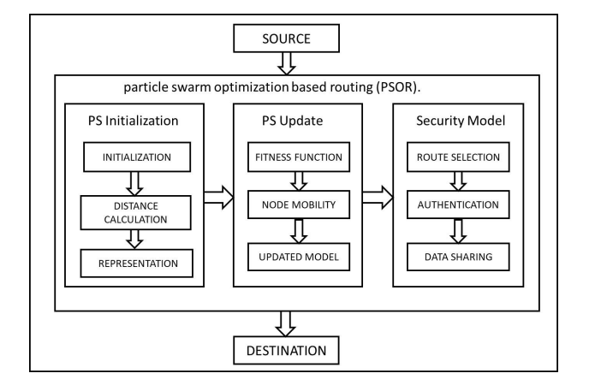
Fig 2: System model for relay-aided D2D communication

C. Network Dynamics and Prediction Metrics
Accurate assessment of network dynamics is essential for selecting stable and long-lasting routing paths. Existing approaches generally distinguish between node-centric and link-centric lifetime estimation techniques. Node lifetime metrics rely on energy-related indicators, such as the Energy Drain Rate (EDR), while link lifetime estimation focuses on mobility characteristics, commonly quantified using Relative Mobility Estimation (RME), which measures how rapidly neighboring nodes move apart. By jointly considering these parameters, routing protocols can estimate the expected longevity of candidate routes and prioritize paths that minimize the need for frequent rediscovery, thereby conserving energy and reducing control overhead.

D. Existing Relay Models
Previous studies on energy-efficient communication have explored relay-assisted schemes such as Joint Power Allocation and Relay Selection (JPARS), particularly in Device-to-Device (D2D) communication scenarios. These approaches typically model D2D pairs as autonomous agents within a cellular framework and employ Mixed Integer Nonlinear Programming (MINLP) formulations to optimize system-wide energy efficiency. Although advanced learning-based techniques, including Q-learning, have been applied for relay selection, such methods often incur high computational costs and lack integrated security handling mechanisms. Moreover, their limited adaptability to rapid changes in node density frequently leads to congestion and increased transmission delays.
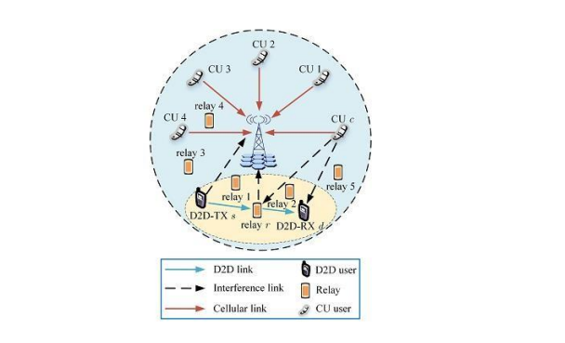
Fig 3. : System model for relay-aided D2D communication
The proposed PSOR protocol overcomes these limitations by combining established routing principles with a layered optimization framework. By jointly considering residual energy and path distance within its fitness evaluation, PSOR effectively reduces maintenance overhead, avoids congestion-prone routes, and enhances overall routing performance in dynamic wireless sensor environments.

- Performance Optimization Strategies
The implementation of the Particle Swarm Optimization-based Routing (PSOR) protocol is structured into three specialized phases designed to address the dynamic challenges of Wireless Sensor Networks (WSNs), such as mobility and rapid energy depletion.

A. Swarm Initialization Phase
This initial stage focuses on the structural deployment and configuration of the network topology within the simulation environment. The network is modeled using a Network Animator (NAM) window, which provides a graphical representation of node interactions. Nodes are deployed using two distinct motion models:
- Random Motion: Nodes are generated at random coordinates within a pre-defined X and Y range, simulating a dynamic environment where sensor placement is unpredictable.
- Fixed Motion: Nodes are assigned specific X and Y dimension positions, reflecting a controlled deployment where sensors remain stationary.
In this phase, every sensor node is designed to be aware of its own geographic coordinates, which can be derived from satellite-based systems like GPS or energy-efficient local localization methods. Furthermore, a neighbor discovery protocol is executed to ensure that each node maintains an updated list of the positions of its immediate neighbors. This awareness is fundamental for greedy geographic routing and the subsequent formation of the ring structure that encapsulates the network center.
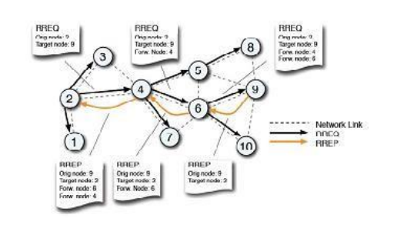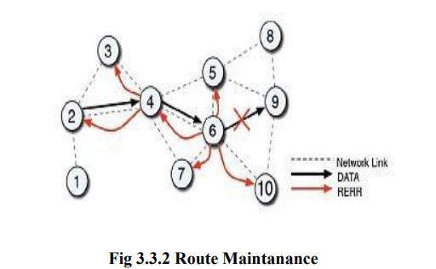

Fig 3.1 : Route Discovery
Fig 3.2 : Route Maintenance
B. Particle Update Phase
The routing problem is formulated as an optimization challenge where candidate paths are treated as "particles" within a swarm. The primary goal is to identify the global best (gBest) path that minimizes energy consumption while maintaining high bandwidth.
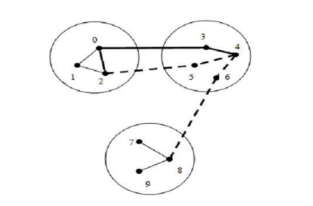
Fig 4 : Region based network topology

1) Fitness Function and Path Selection
The efficiency of each potential path is evaluated using a fitness function that prioritizes distance, as energy consumption in WSNs is directly proportional to the transmission distance. The fitness value is calculated as:
Fitness=dist(i,j)+dist(j,base)
where i and j represent the coordinates of intermediate nodes and the base station. A lower fitness value indicates an optimal solution with reduced energy dissipation.
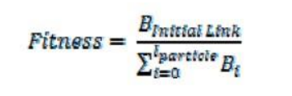

2) Mathematical Update Model
The algorithm iteratively improves these candidate paths by updating the velocity and position of each particle. In an n-dimensional search space, the update equations are:
- Velocity Update:
vid​=w⋅vid​+c1​r1​(pid​−xid​)+c2​r2​(pgd​−xid​)
- Position Update: xid​=xid​+vid​
Here, pid​ represents the "personal best" (pBest) position found by the individual particle, and pgd​ represents the "global best" (gBest) found by the entire swarm. The parameters c1​ and c2​ are cognitive and social scaling constants, respectively, while w is the inertia weight used to balance the exploration of new paths with the exploitation of known efficient routes. To translate these real-number values into the natural number system used for node indexing, a Shortest Positioning Indexing method is applied to sort and simplify node positions.

C. Secure Routing Selection
The final phase implements a region-based topology and a grading system to ensure the reliability and security of data transmission.

1) Region-Based Management and Priority
The network is divided into specific regions, and each node within a region is assigned a priority value based on its current status. A high priority indicates an active node capable of secure transmission, while nodes that have already been selected for a path are assigned a large negative value to avoid loops and backtracking. The system utilizes a heuristic operator (M) defined by the number of nodes in each region to calibrate the routing process.

2) Two-Level Graded Functions
The system evaluates route availability through a dual-level grading process:
- Level-1 Operation: This identifies "non-production" nodes—those experiencing congestion or possessing limited resources. Each node is assigned a grade value ranging from -3 to +3 to signify its productivity. Only the top three priority nodes in each region that satisfy a specific relaxation range (0 to 2) are selected for further consideration.
- Level-2 Operation: The topology from Level-1 is used to build a connectivity graph between regions. PSO selection is then applied based on bandwidth availability to determine the final optimal path leading to the destination.

3) Route Recovery and Authentication
To maintain network robustness, a proactive route recovery mechanism is integrated. The system uses fuzzy rules to continuously monitor node status; if a node is identified as "weak" due to energy depletion, the traffic is automatically diverted to "stronger" neighbor nodes. This prevents data loss and reduces communication overhead. Finally, the secure routing model includes an authentication step to ensure that data sharing occurs only between verified nodes, maintaining the integrity of the information throughout the transmission process.
To further expand on the technical implementation of the PSOR protocol, the following sections detail the optimization of standard protocol behaviors and the underlying simulation architecture used to validate the system.

D. Protocol Optimization and Recovery Refinements
The implementation process incorporates significant optimizations to standard protocol behaviors to better suit the resource-constrained WSN environment. While the standard Ad Hoc On-Demand Distance Vector (AODV) protocol typically relies on periodic HELLO messages for link breakage detection, this implementation adopts an AODV-LL (Link Layer) approach. By utilizing link-layer feedback from the 802.11 standard instead of periodic beacons, the system eliminates substantial control overhead, which has been shown to perform significantly better in dynamic topologies. Furthermore, the implementation strategically shortens the Route Reply (RREP) wait time from the default 120 seconds to 6 seconds. This adjustment aligns with the 3-second timeout for reverse route information, allowing the protocol to recover from dropped packets much more rapidly and re-initiate route discovery before the network state becomes obsolete.

E. Event-Driven Simulation and Buffering Logic
To ensure the proposed routing logic translates into reliable network performance, the system is deployed within the NS-2 (Network Simulator 2) environment, leveraging its object-oriented, event-driven architecture. The implementation uses C++ for core routing logic to ensure computational speed, while OTcl (Object Tool Command Language) is used as a front-end to define complex simulation scenarios and network topologies. Central to this architecture is the Event Scheduler, which manages concurrent data transmissions using a First-In-First-Out (FIFO) mechanism to prevent congestion at the node level during high-traffic periods. During the initial route discovery phase, data packets are not immediately discarded; instead, they are buffered at the source’s PSO router. This configurable buffer ensures that older packets are only discarded when the limit is reached, maintaining a high packet delivery ratio while the PSOR algorithm identifies the most energy-efficient global best path.
- Experiment Results and Analysis
To evaluate the performance and efficiency of the proposed Particle Swarm Optimization-based Routing (PSOR) protocol, extensive simulations were conducted using NS-2 (Network Simulator 2). The performance of the PSOR framework was benchmarked against the Genetic Algorithm (GA), a common baseline in existing network optimization studies. The experimental setup involved varying the number of sensor nodes and users to test the scalability and robustness of the algorithms in dynamic environments.

A. Connectivity Rate
The connectivity rate is a vital metric for assessing the stability of a mobile ad hoc network. Simulation results indicate that the proposed PSOR framework maintains a superior and more consistent connectivity rate as the network scale increases. While traditional GA-based models often struggle with link breakages caused by node mobility, the PSOR protocol’s region-based topology and proactive neighbor discovery allow it to sustain stable communication links.
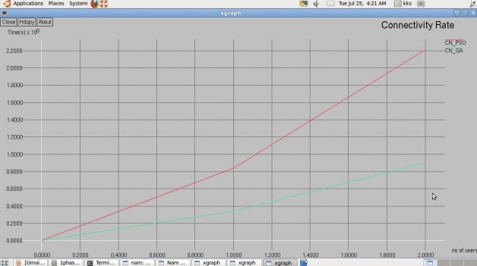

B. End-to-End Delay
Transmission latency is a critical factor for Quality of Service (QoS) in Wireless Sensor Networks. The results demonstrate that PSOR exhibits a significantly lower end-to-end delay compared to the existing GA-based framework. By identifying the "Global Best" ($gBest$) path—the shortest route in terms of distance and cost—the PSOR algorithm ensures that data packets are delivered with minimal lag. This efficiency is further supported by the event-driven scheduler in NS-2, which prevents data congestion during high-traffic periods.
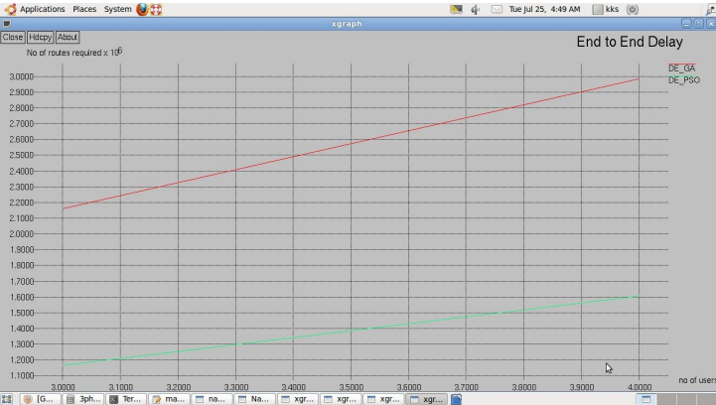

C. Energy Consumption
Energy efficiency is the primary objective of this research. Comparative analysis shows that PSOR provides markedly better results than the Genetic Algorithm in terms of energy preservation. While GA often exhausts the battery of nodes on the shortest path, leading to early network partitions, PSOR utilizes a fitness function that balances path length with residual energy. This leads to a more uniform distribution of energy dissipation across the network, effectively maximizing the operational lifetime of all sensor nodes.
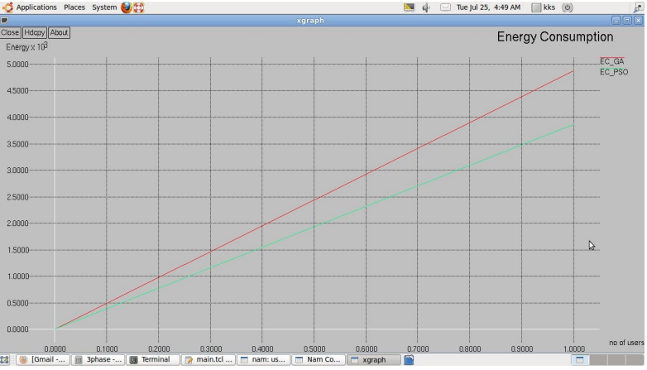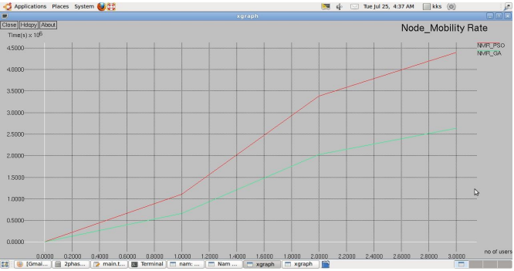

D. Packet Delivery Ratio (PDR) and Throughput
The reliability of the network was assessed through the Packet Delivery Ratio and Average Throughput.
- Packet Delivery Ratio: PSOR achieves a significantly higher PDR compared to the baseline frameworks. This is largely due to the integrated route recovery mechanism, which diverts traffic from "weak" nodes to "stronger" neighbors before communication fails.
- Throughput: The throughput ratio for the PSOR framework remains high even as node density increases, outperforming existing methods⁸⁸⁸⁸. The algorithm's ability to handle high flow rates without buffer overflows ensures a steady and successful exchange of packets across the network.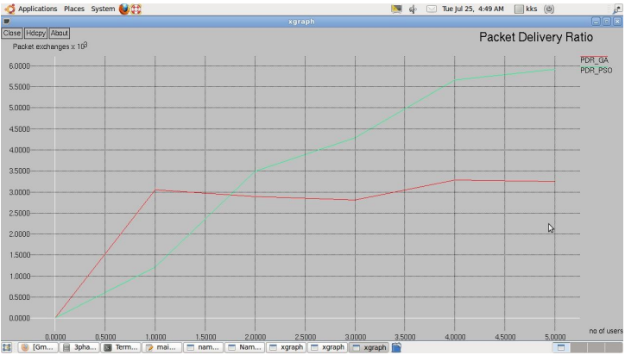
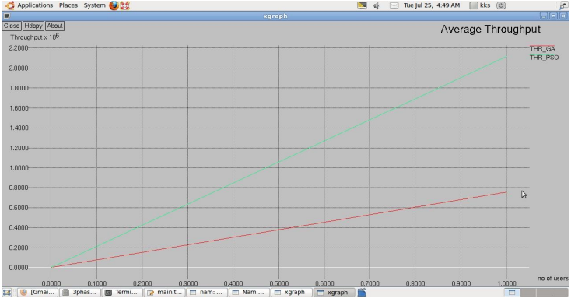

E. Execution Time and Efficiency
Beyond network performance, the computational efficiency of the algorithm was measured. PSOR demonstrated a lower Execution Time Ratio than the Genetic Algorithm, proving that it can converge on an optimal routing path more rapidly. For low-power sensor nodes with limited processing capabilities, this fast convergence is essential for minimizing the energy overhead of the routing protocol itself.
In summary, the experimental results provide conclusive evidence that the PSOR protocol is a more effective method for optimizing Wireless Sensor Networks than existing GA-based approaches, delivering superior performance across all critical evaluation metrics
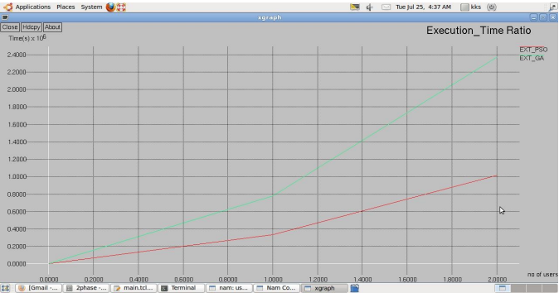

- Conclusion

We propose a routing protocol called Particle Swarm Optimization based Routing (PSOR) that aims to maximize the lifetime of Wireless Sensor Networks (WSNs) by prioritizing energy efficiency. Our algorithm utilizes the Particle Swarm Optimization (PSO) strategy to determine an optimized routing path for data forwarding and processing towards the base node. In PSOR, we evaluate the energy levels of nodes and the lengths of potential routes to generate a new routing path. The fitness value of each path is determined based on its energy consumption, and we select the path with the lowest energy consumption as the optimized route. Additionally, we incorporate a route recovery mechanism to handle weak nodes by diverting routes to stronger nodes. By considering the energy consumption associated with longer distances traveled to send data, our algorithm effectively reduces data loss and communication overhead. Simulation results demonstrate that PSOR outperforms other protocols, reducing congestion delay and increasing the network lifetime. Our research highlights the significance of energy efficiency in WSNs and the effectiveness of PSO in optimizing routing paths.

- References

[1] H. Li, X. Lin, H. Yang, X. Liang, R. Lu, and X. Shen, “EPPDR: An Efficient Privacy-Preserving Demand Response Scheme with Adaptive Key Evolution in Smart Grid,” IEEE Transactions on Parallel and Distributed Systems, vol. 25, no. 8, pp. 2053–2064, 2014.
[2] S. Sun, L. Gong, B. Rong, and K. Lu, “An intelligent SDN framework for 5G heterogeneous networks,” IEEE Commun. Mag., vol. 53, no. 11, pp. 142–147, Nov. 2015.
[3] L. Fawcett, S. Scott-Hayward, M. Broadbent, A. Wright, and N. Race, “Tennison: A distributed SDN framework for scalable network security,” IEEE J. Sel. Areas Commun., vol. 36, no. 12, pp. 2805–2818, Dec. 2018.
[4] A. DeGante, M. Aslan, and A. Matrawy, “Smart wireless sensor network management based on software-defined networking,” in Proc. IEEE Commun. Biennial Symp., Jun. 2014, pp. 71–75.
[5] S. W. Pritchard, G. P. Hancke, and A. M. Abu-Mahfouz, “Security in software-defined wireless sensor networks: Threats, challenges and potential solutions,” in Proc. IEEE 15th Int. Conf. Ind. Informat. (INDIN), Jul. 2017, pp. 168–173.
[6] C. Habib, A. Makhoul, R. Darazi, and C. Salim, “Self-adaptive data collection and fusion for health monitoring based on body sensor networks,” IEEE Trans. Ind. Informat., vol. 12, no. 6, pp. 2342–2352, Dec. 2016.
[7] P. Perera and V. M. Patel, “Efficient and low latency detection of intruders in mobile active authentication,” IEEE Trans. Inf. Forensics Security, vol. 13, no. 6, pp. 1392–1405, Jun. 2018.
[8] S. Borasia and V. Raisinghani, “A review of congestion control mechanisms for wireless sensor networks,” Springer Berlin Heidelberg Technology Systems and Management, pp. 201–206, 2011.
[9] A. Rezaei and M. K. Rafsanjani, “Congestion control protocols in wireless sensor networks: A survey,” Journal of American Science, vol. 8, no. 12, pp. 772–777, 2012.
[10] C. Luo and W. X. Xie, “Fuzzy AQM for congestion avoidance and control in sensor networks,” Chinese Journal of Electronics, vol. 42, no. 4, pp. 679–684, 2014.
[11] S. Latif, S. Ahmed, and Z. Ali, "Energy-efficient routing in wireless body area networks: A survey," IEEE Access, vol. 8, pp. 216590-216615, 2020.
[12] M. S. J. Singh and J. Malhotra, "A comprehensive review on particle swarm optimization (PSO) and its variations in wireless sensor networks," Materials Today: Proceedings, 2021.
[13] J. Kennedy and R. Eberhart, "Particle swarm optimization," in Proceedings of ICNN'95 - International Conference on Neural Networks, vol. 4, pp. 1942-1948, 1995.
[14] S. Arjunan and P. Sujatha, "Lifetime maximization of wireless sensor networks using fuzzy based unequal clustering and PSO-based routing hybrid protocol," Applied Intelligence, vol. 48, no. 8, pp. 2229-2246, 2018.
[15] A. K. Dwivedi and O. P. Vyas, "An energy efficient PSO-based clustering and routing protocol for WSNs," Wireless Personal Communications, vol. 110, pp. 1709-1729, 2020.
[16] F. Z. Messous et al., "A survey on relay selection in wireless sensor networks," Journal of Network and Systems Management, vol. 28, no. 4, pp. 1215-1277, 2020.
[17] Y. Qu et al., "A survey of routing protocols for wireless body area networks," Sensors, vol. 19, no. 7, p. 1584, 2019.

